

CMPE235: Mobile Software Design

Fall 2017

Lab Assignment 1:

Smart Trees

Submitted to:

Dr. Jerry Gao

San Jose State University

Submitted by:

Pooja Shah 010828311

1 Lab Assignment Description

This assignment is designed to learn implementation and design of Smart Trees mobile application. In this assignment, I chose to build iOS based mobile application to interact with the trees. Application consists of features like Interacting with tress using QR code of the tree, about, nearby business, capturing photo and sharing it on social networking website , rating of the street and many more.

Project deliverable

1. Demo : <https://youtu.be/zUSuSw7BdbM>

2. Document

3. Source Code

2 Requirements

This iOS application contains following requirements to fully cover the expected experience from client user.

2.1 2D QR code image capture, decoding, display, and click-through “Abut”

As the main function of this application, it contains the function of QR code scan. Users have the QR code which provided by tree where user is located, they should use this function to scan the code and view current street information.

2.2 “Interact” Trees

User can look more information of tree as well as other trees and locate the other trees along with light sensor status

2.3 Nearby

User should capable to use this function to view the business such as restaurant, shopping etc. user can also do custom search and use map feature to drive along based on current location

2.4 Snap

User can click a picture and save it as memory

2.5 Share

User can share the photo taken from photo library on Facebook , Twitter

2.6 Comments

User can view the comments as well as rate as well

3 Technologies

* Swift based application
* Yelp Integration
* iOS Location and MapKit
* QRCode Reader API based on AVFoundation
* Facebook and Twitter integration
* Dealing with privacy such as Photo Library, Location etc.

4 Application behavior

1. Launch Screen of App

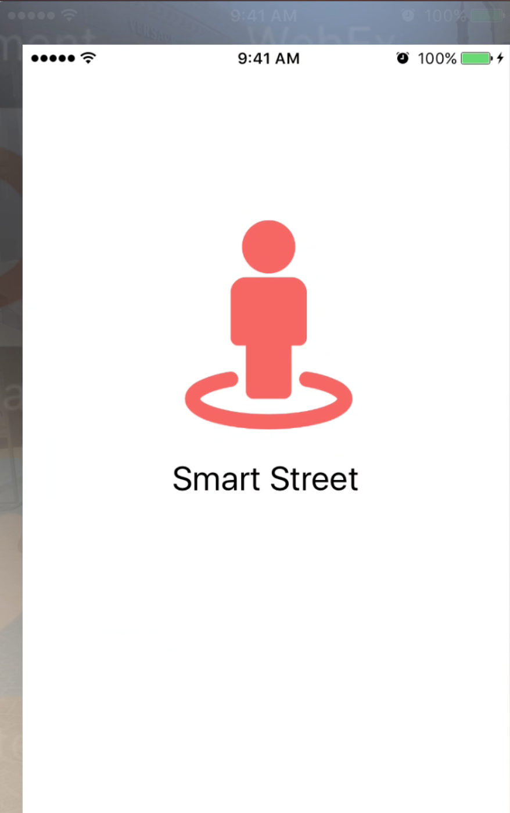

Fig 1. Launch screen

1. Menu items as described in Requirements

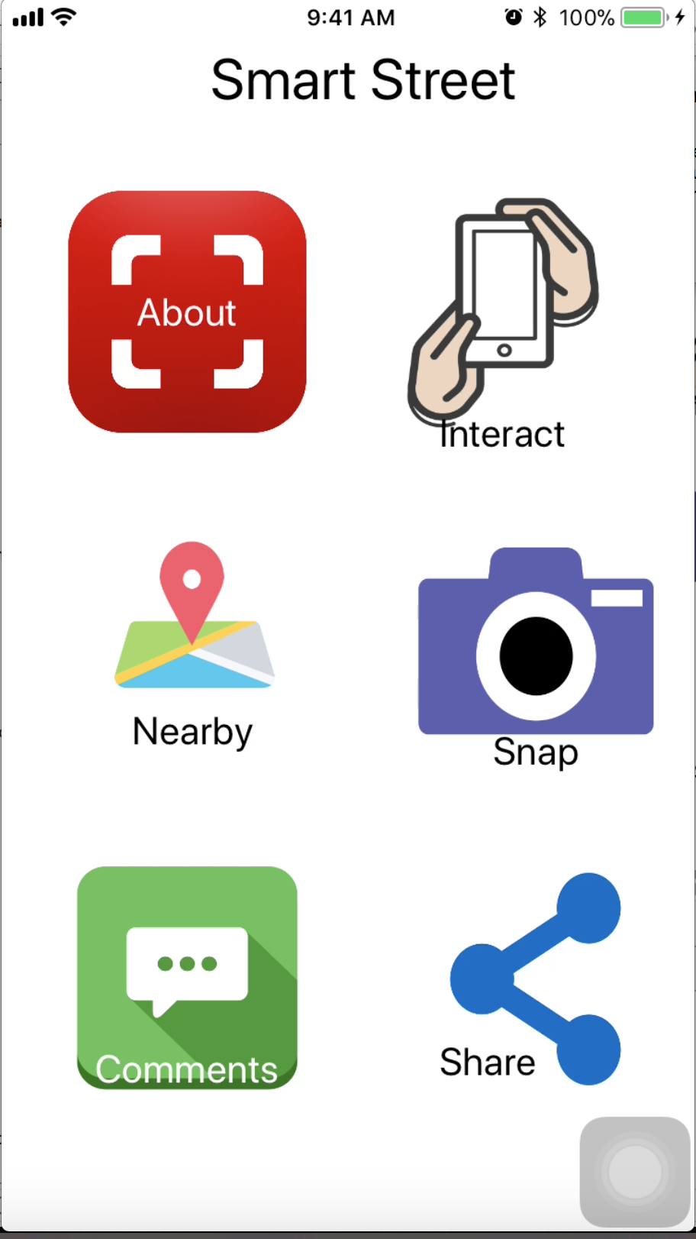

Fig 2. Menu

1. As shown in in fig 3. After clicking on Interact, scanning of QR code can be done

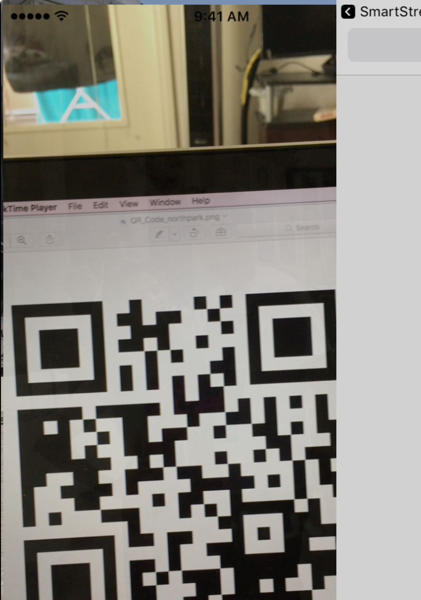

Fig 3. Scanning QR

1. Fig 4 shows Corresponding details of the tree will be displayed on URL linked to the QR code

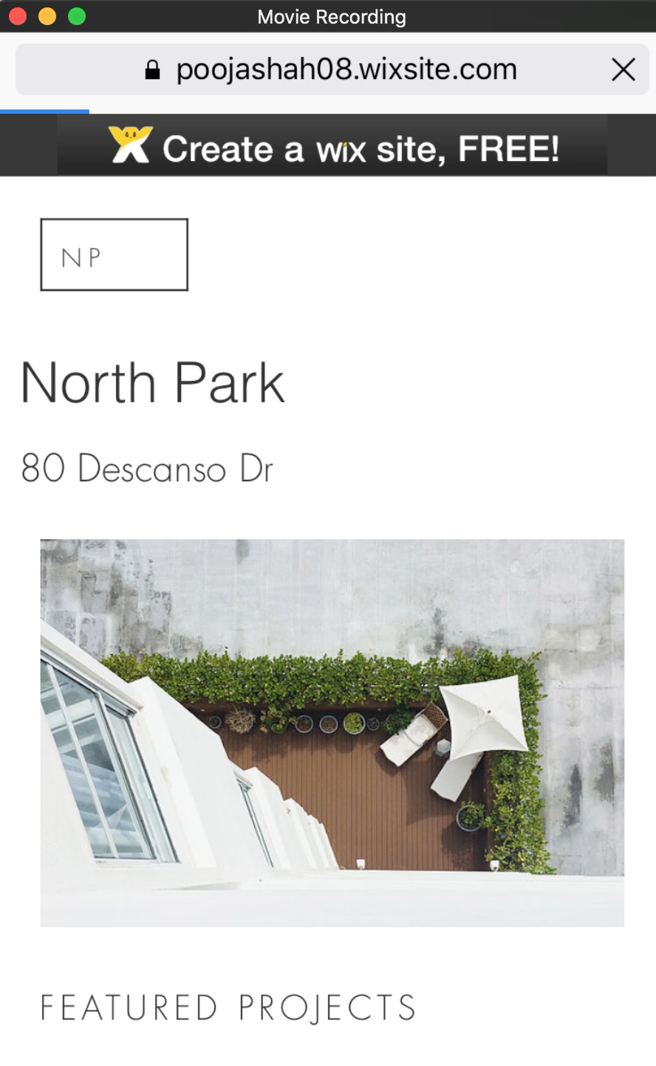

Fig 4. Interaction with Tree

1. As shown in in Fig 5. After clicking on About, tree information along with other trees nearby you, will be displayed. You can click on tree and find the location. Light Sensor status will be also displayed.

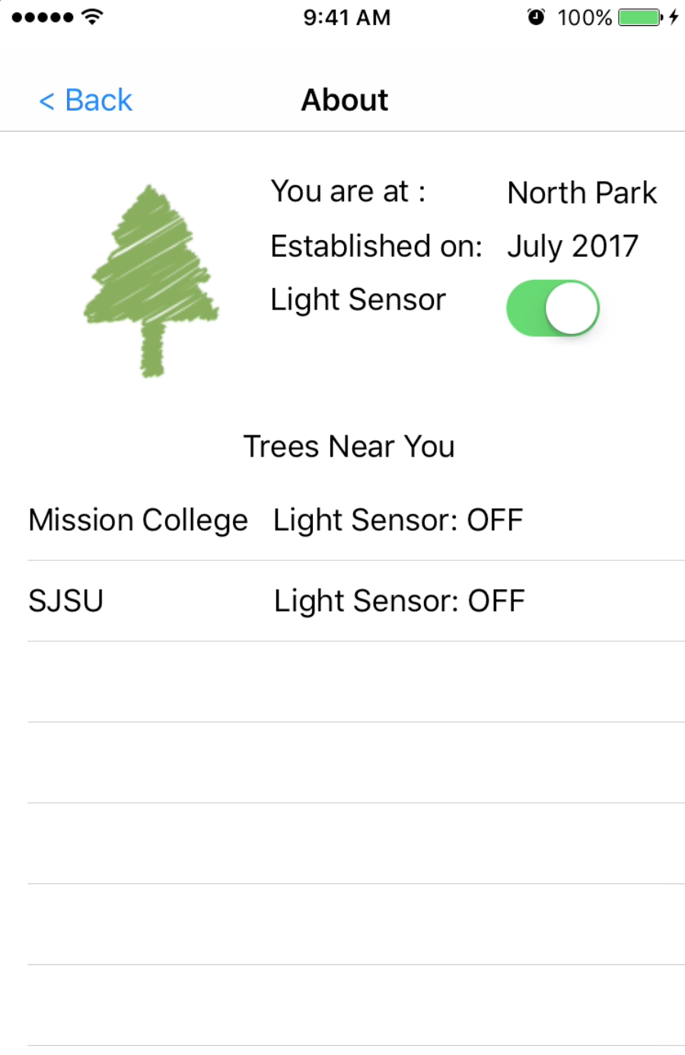

Fig 5. About

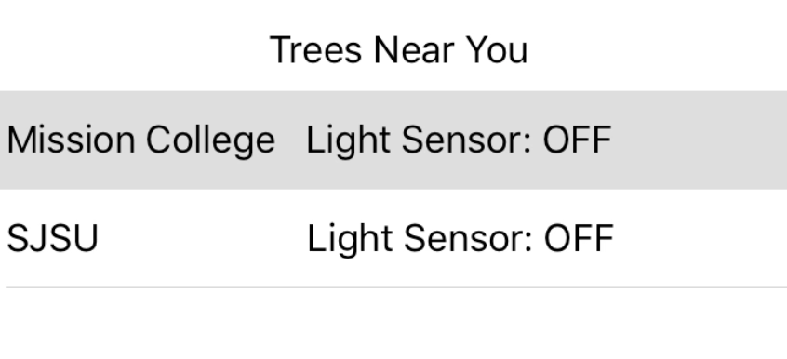

Fig 6. Select nearby tree

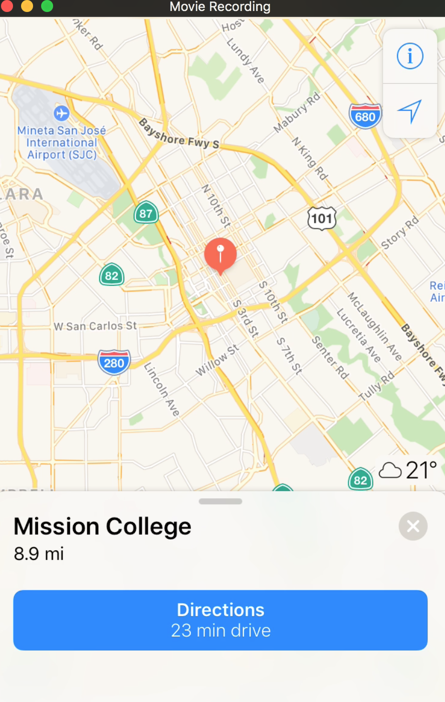

Fig 7. Location of tree



Fig 8. Menu

1. After clicking on “Snap”

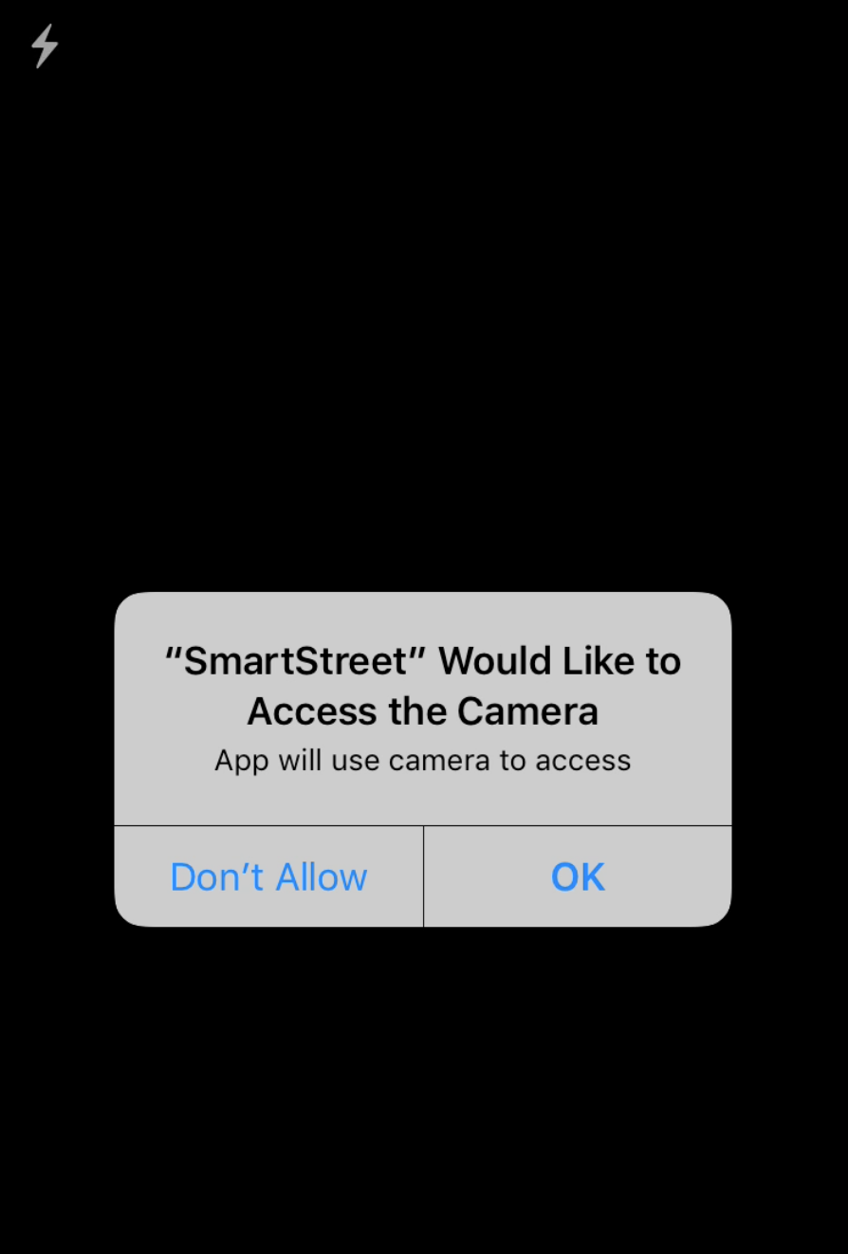

Fig 9. After clicking on Snap

1. Click on hand and take photo

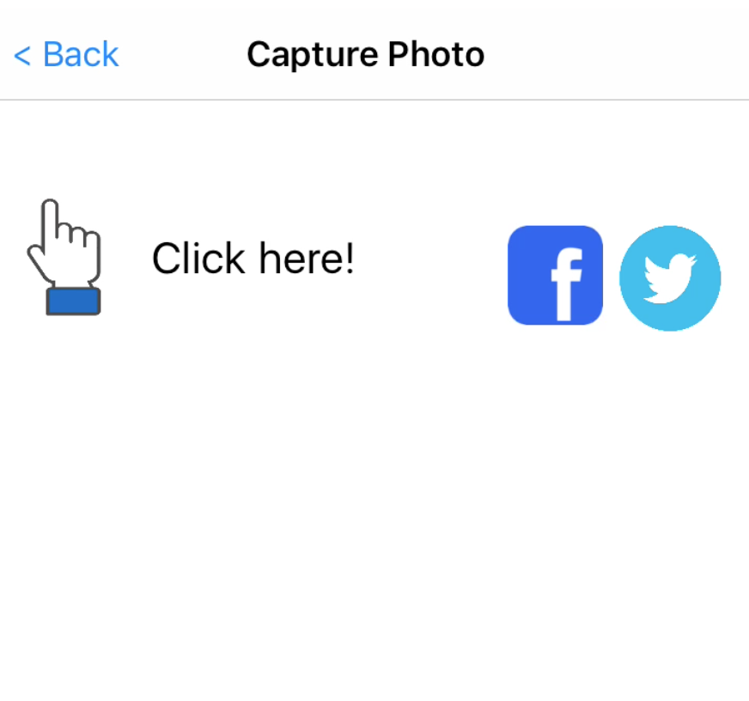

Fig 10 . Click to take picture

1. As shown in Fig 11, photo will be saved in phot library.

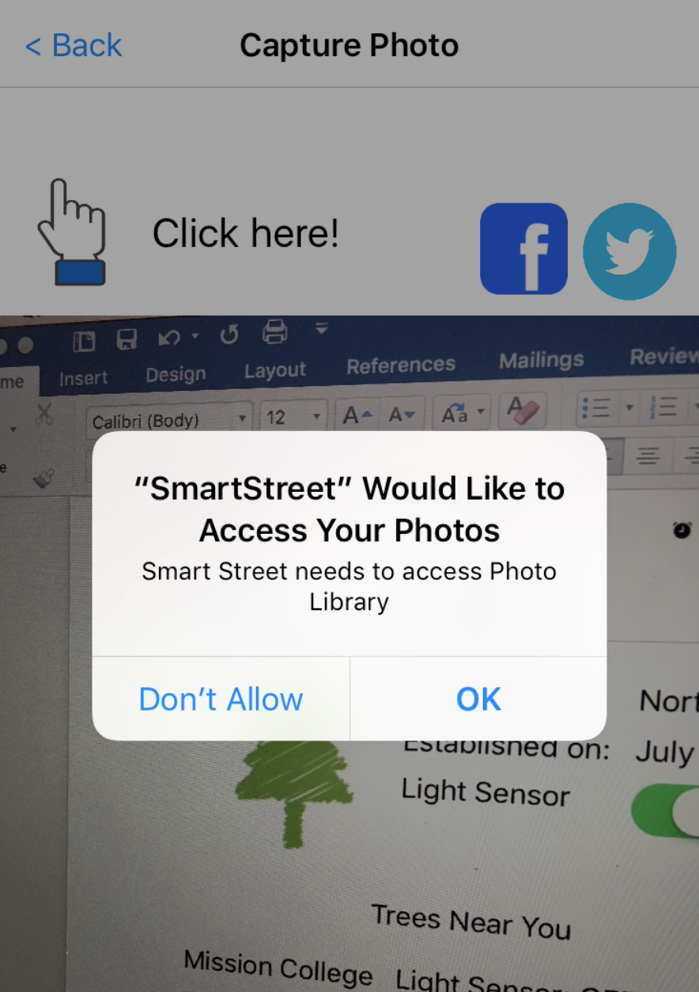

Fig 11. Photo will be saved in library

1. You can also share it on Facebook and twitter as shown in in fig 12.



Fig 12. Share on Social networking

1. Sharing Post on Facebook



Fig 13. Select photo and Share on Facebook

1. Sharing Tweet on Twitter

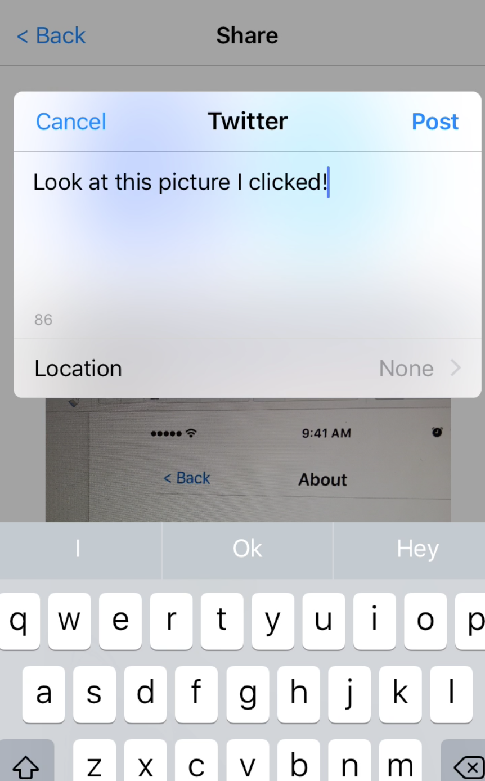

Fig 13. Select photo and Share on Twitter



Fig 14. Menu

1. Click on Nearby and your current location will be detected. Used **Yelp APIs** to pull the nearby business you can also drive to that location.

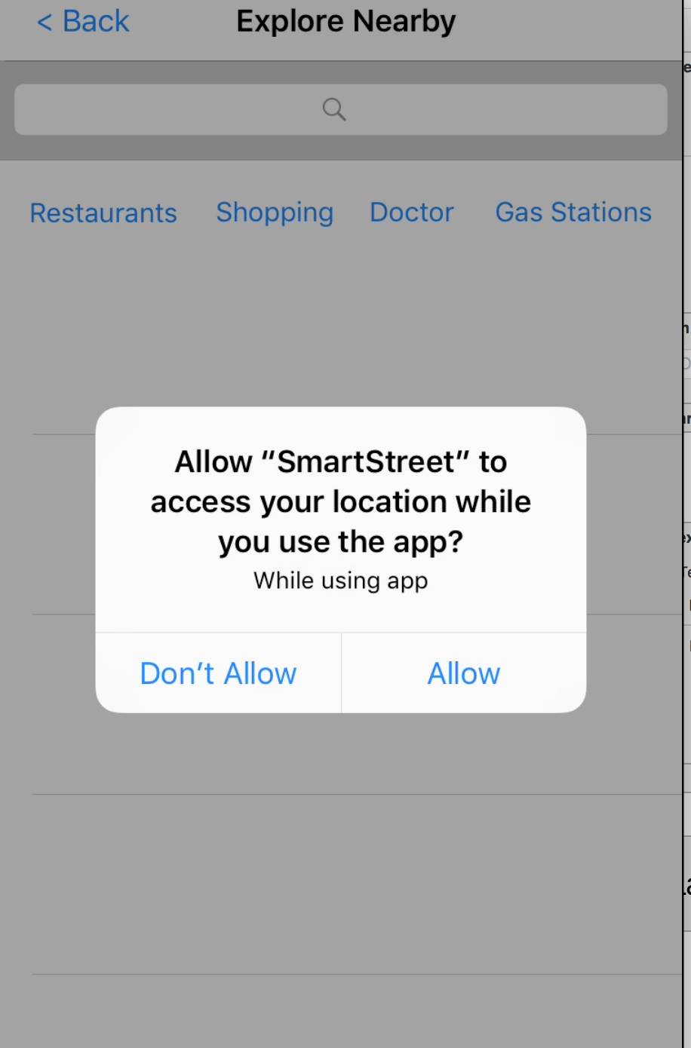

Fig 15. Location

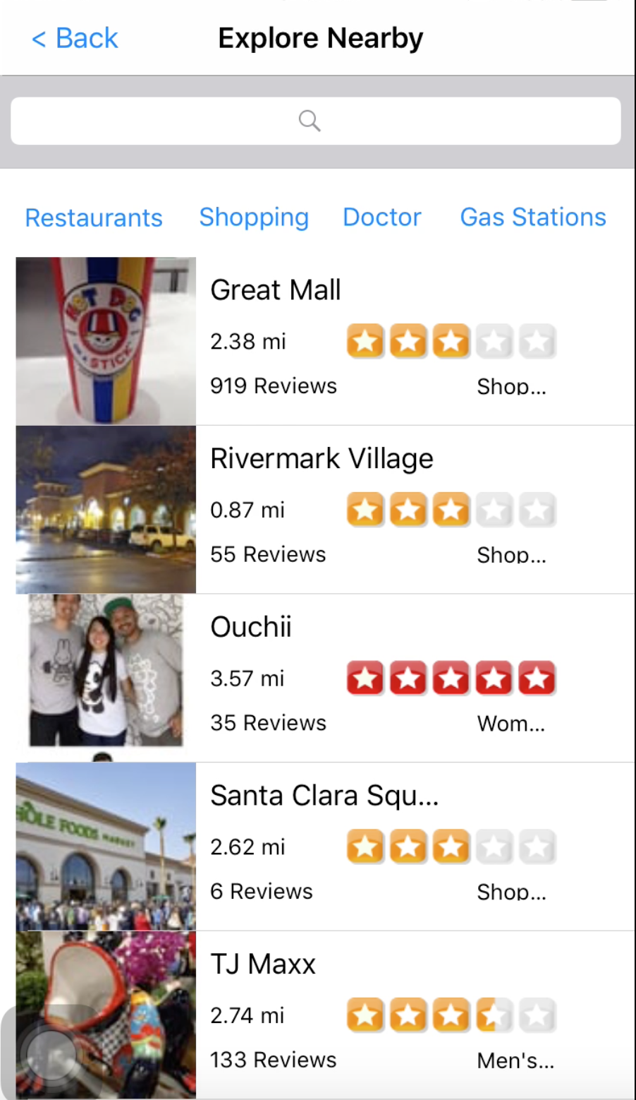

Fig 16. Yelp location

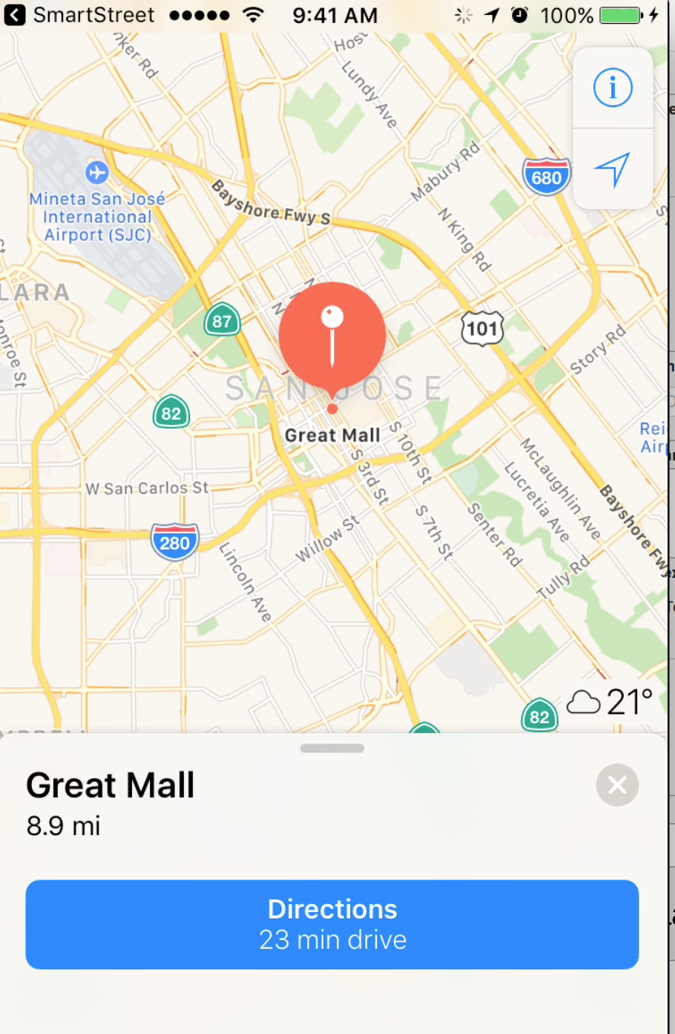

1. Click on **Comments**. You can find the comments listed for the street as show in in fig 17.

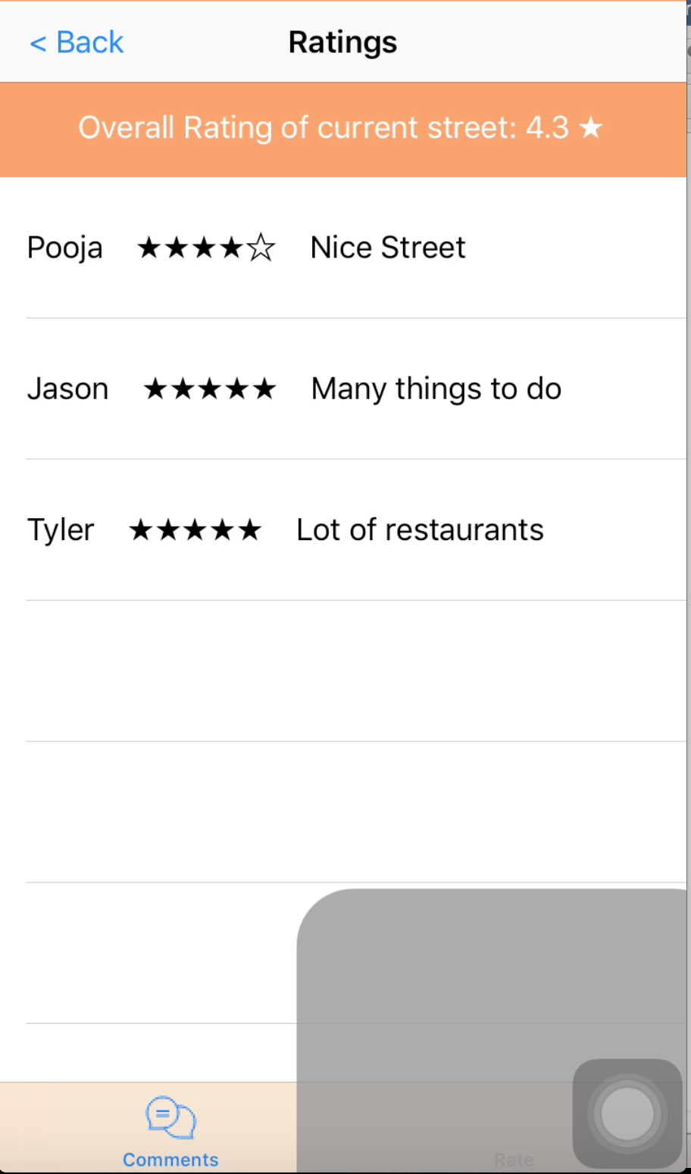

Fig 17. Comments

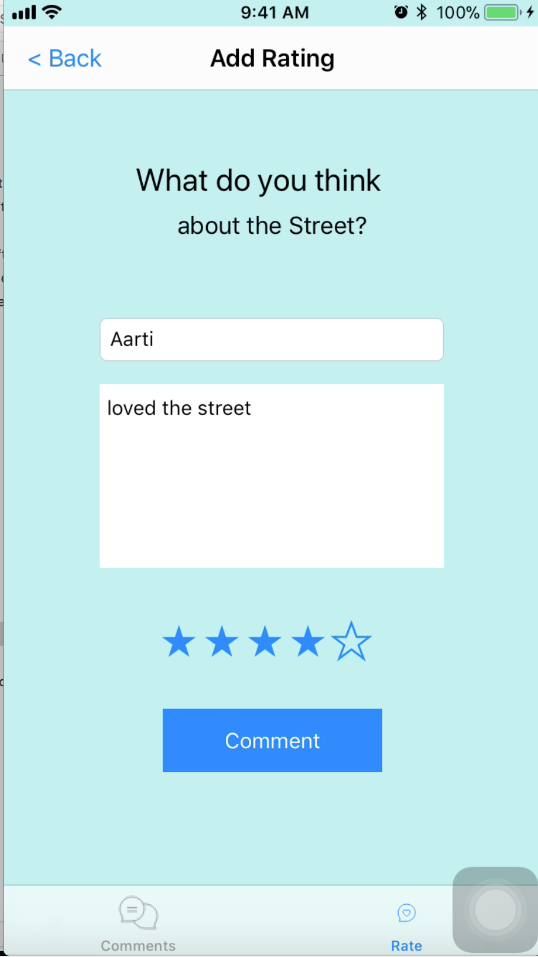

Fig 18 . Add Comment

1. Add a comment and rate the street. Navigate back to favorites and see the added comment listed.

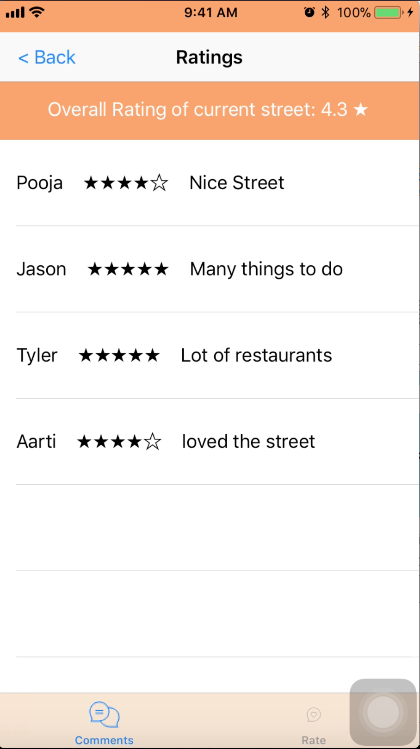

Fig 19. After posting a comment

4 Conclusion

Successfully completed the Smart Street mobile application using iOS Swift.